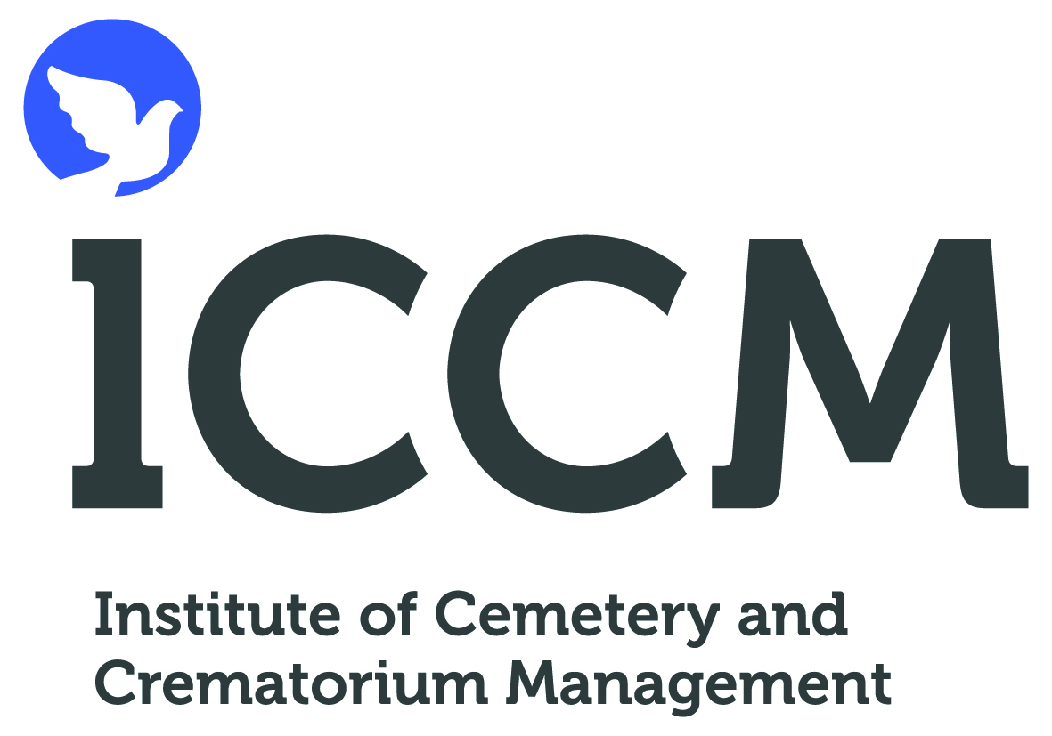

Recycling of Metals Following Cremation
Model Press Release

At some time in our lives we may need to have an operation to replace a joint or have a metal insert to assist the repair of a bone. Often we will die with these metal implants still in our body. We may then be cremated and these metal implants remain in the ashes following the cremation.
At present these metal implants, along with the remaining metals from the construction of the coffin, are removed from the ashes and stored until there is a sufficient quantity to be taken out into the grounds and buried to the detriment of the environment. In a time when environmental issues are becoming more and more important to us all, we are realising that we cannot continue to take action that is detrimental to our environment, without accepting the consequences of our actions some time in the future ???? Crematorium has reviewed current practices in line with recent national guidance from the Institute of Cemetery and Crematorium Management (ICCM).A number of issues have arisen from the review:
- There is an opportunity to recycle the metals that remain after a cremation and ensure that the use of non-renewable resources is minimised, thus helping protect our long term environment
- We should seek the consent of the bereaved before we take any action to dispose of metals following a cremation. The bereaved will now be asked to consent to the sensitive recycling of the metals rather than their disposal in the grounds of the crematorium. The metals can be returned to the family if they so wish
- Soft/precious metals melt during the cremation process and are dispersed throughout the remains and the cremator and are reduced to tiny granules. These cannot be recovered and returned to the family so it is recommended that all jewellery is removed prior to cremation
As from ….(date)… we will be revising our documents for cremation to seek consent for the sensitive recycling of the metals. Arrangements are in place with the ICCM to ensure the highest standards of collection are maintained. The improved arrangements for dealing with metals will not cost the bereaved and may raise a small amount of money from the process. The ICCM has assured all crematoria that any monies raised from this process will be donated to death related charities such as the Heart Foundation and Cancer Research. Full records of all collections, monies raised and charities that have benefited from the process will be available for inspection at the crematorium when the scheme is properly established. Should you have any questions about the new arrangements, please contact the crematorium on Tel. No. ????.

ISSUED BY: The Institute of Cemetery & Crematorium Management
ICCM National Office, City of London Cemetery, Aldersbrook Road, Manor Park, London E12 5DQ
Tel: 020 8989 4661 Fax: 020 8989 6112. Website: www.iccm-uk.com

